**MY LAB PRACTICALS**

**LAB 1**

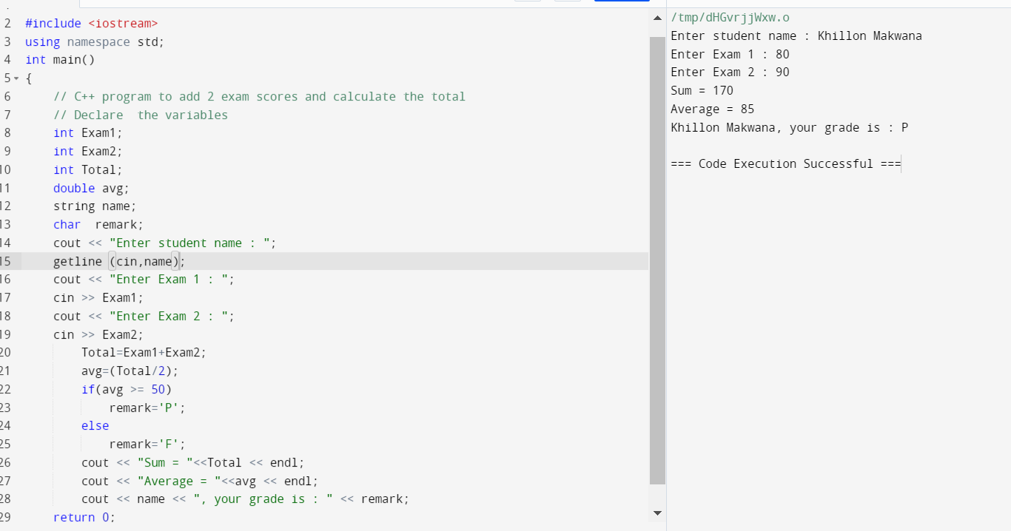

**LAB 2**

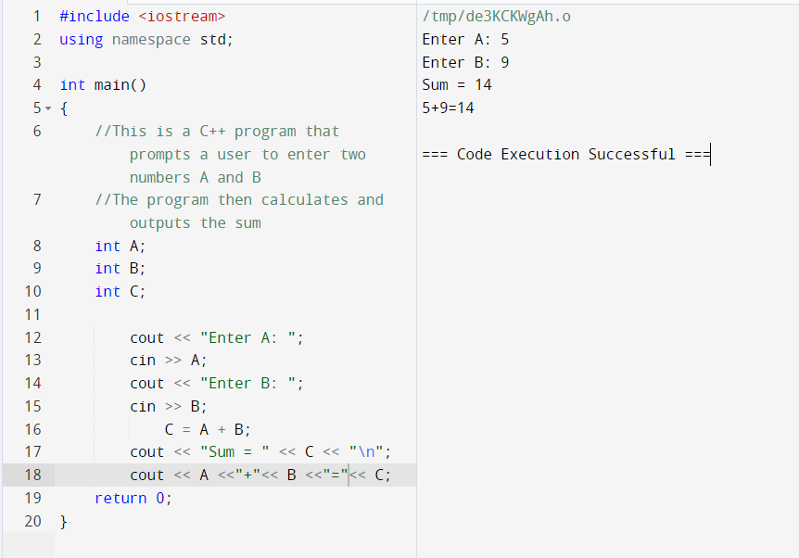

**LAB 3**

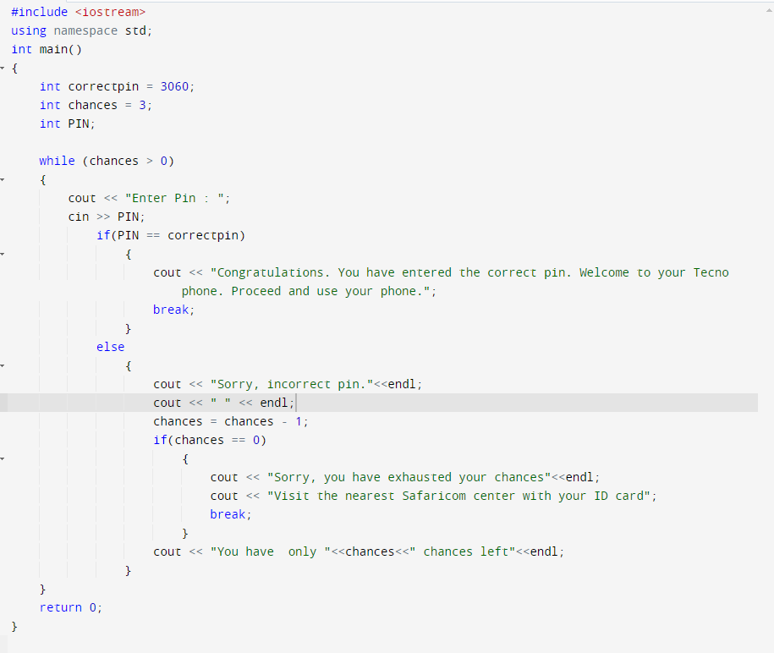

**LAB 4**

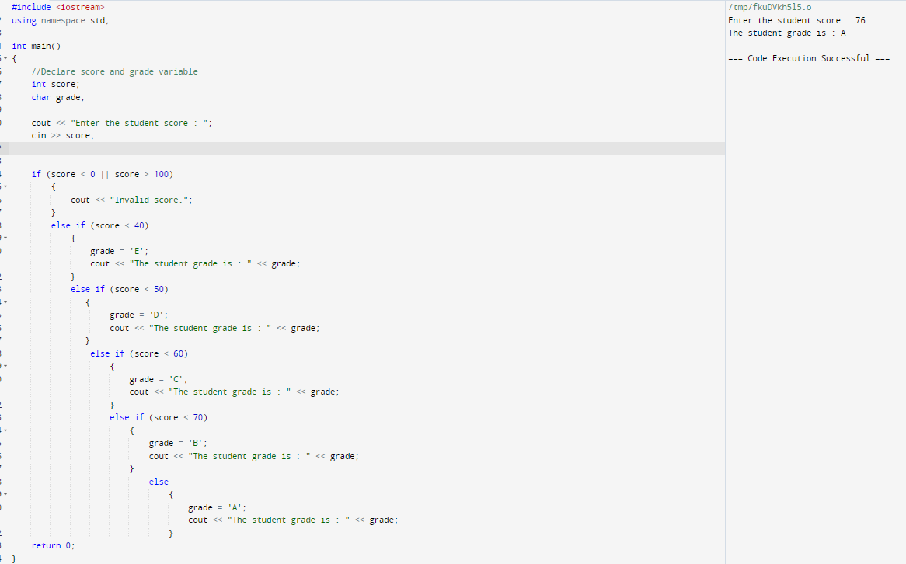

**LAB 5**

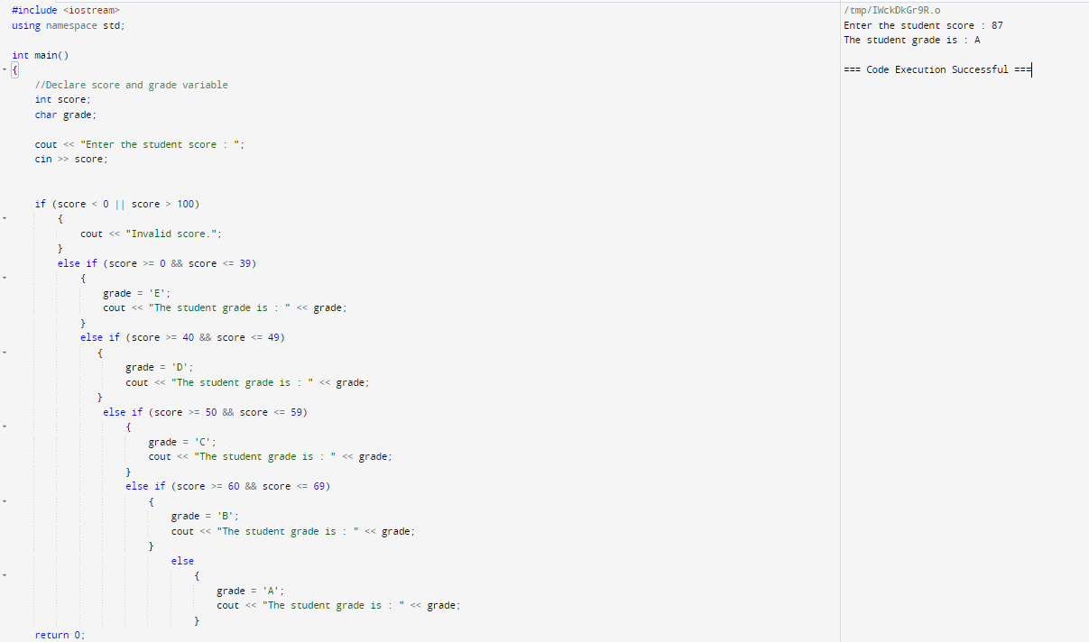

**LAB 6**

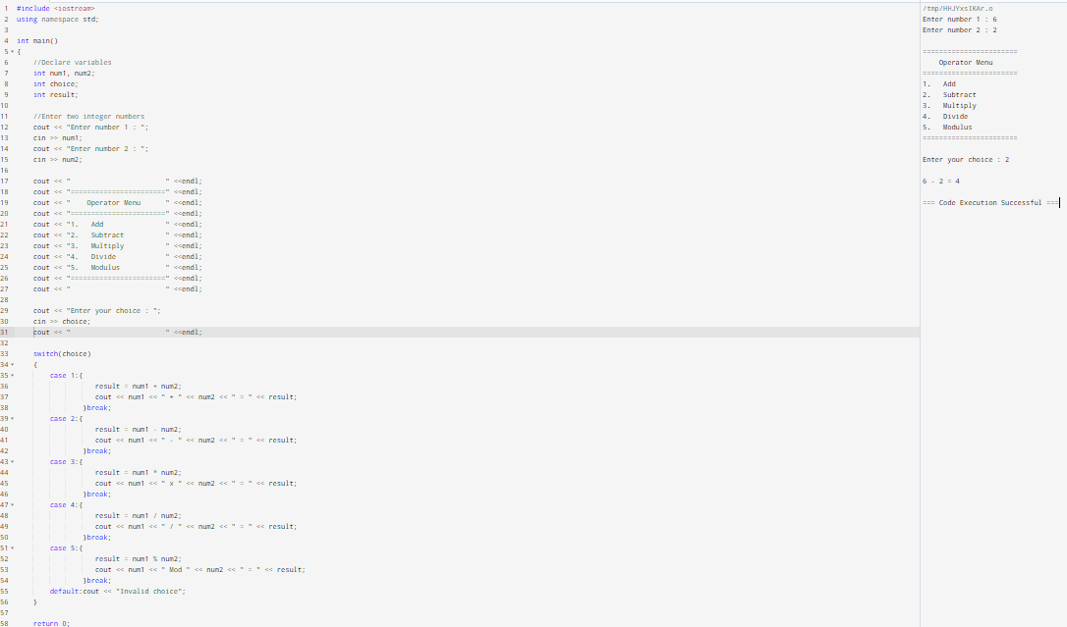

**LAB 7**

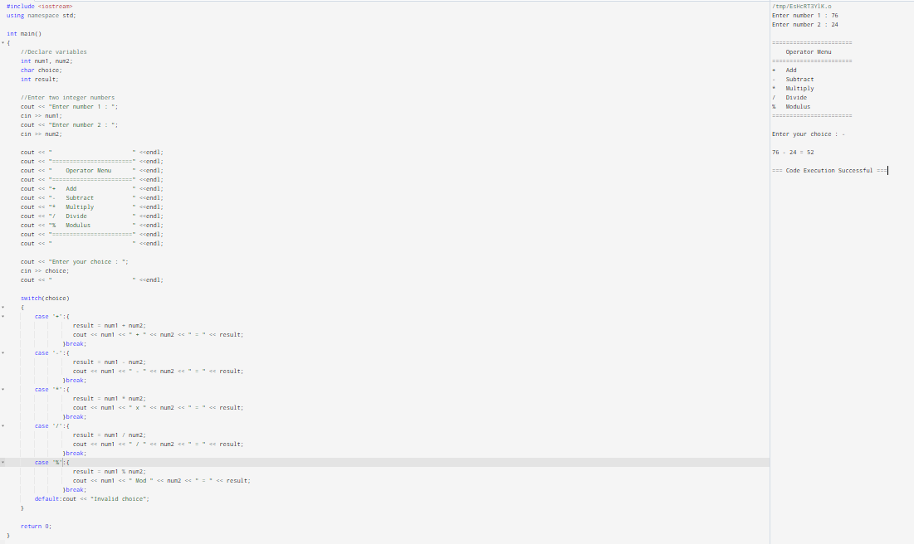

**LAB 8**

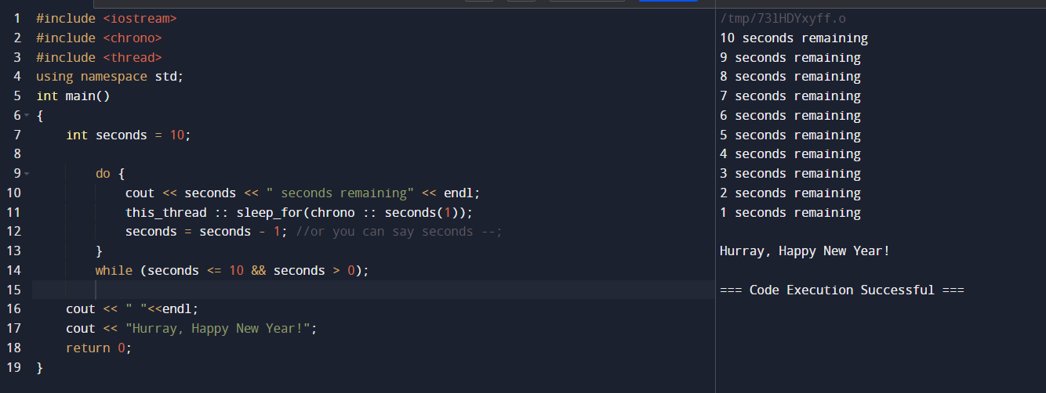

**LAB 9**

**LAB 10**

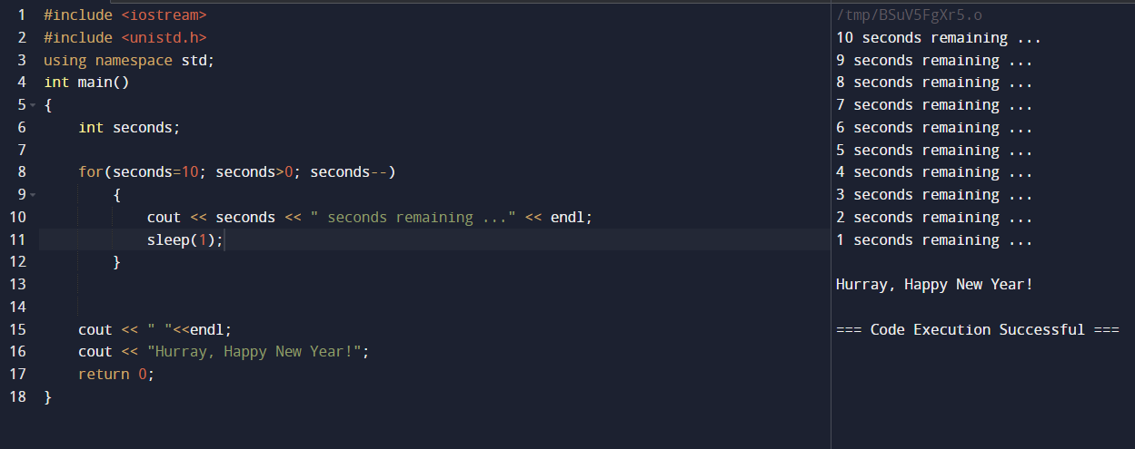

**LAB 11**

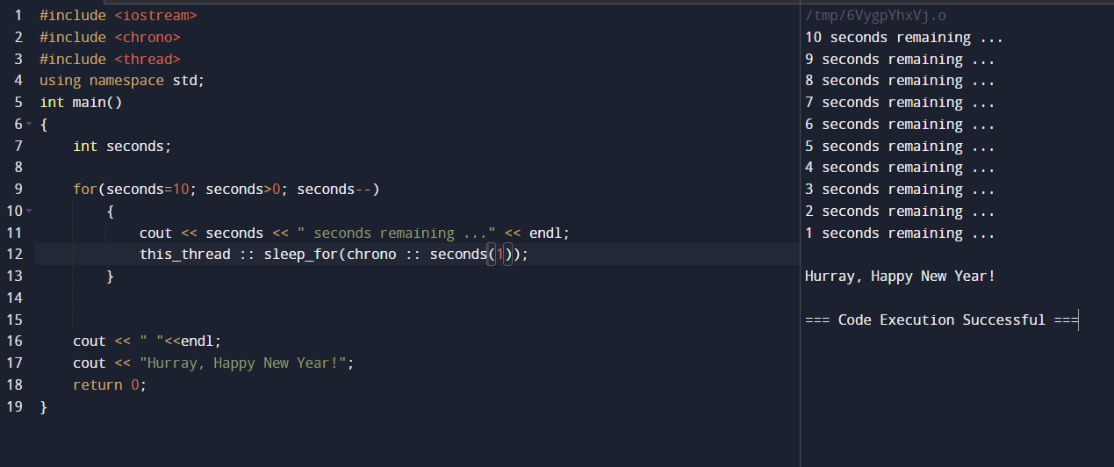

**LAB 12**

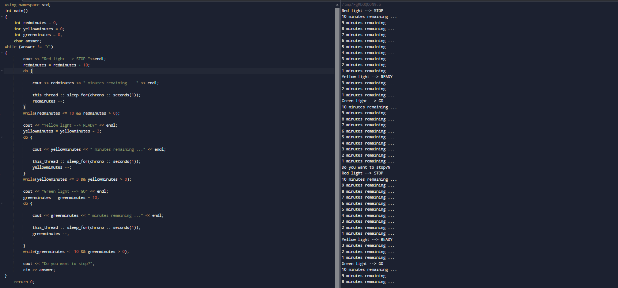

**LAB 13**

Execution stops when the if condition is met

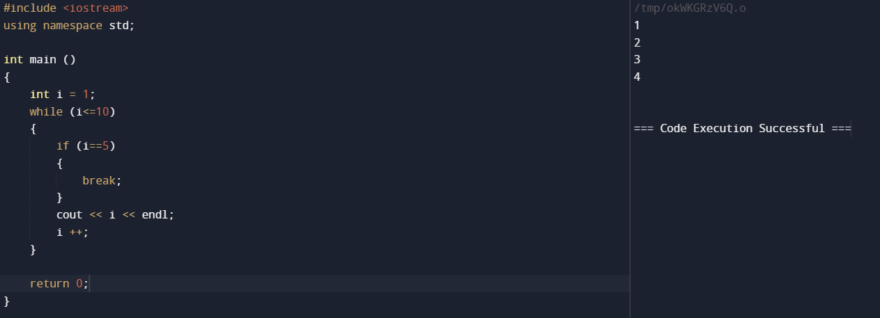

**LAB 14**

4 is left out

**LAB 15**

**LAB 16**

**LAB 17**

**LAB 18**

**LAB 19**

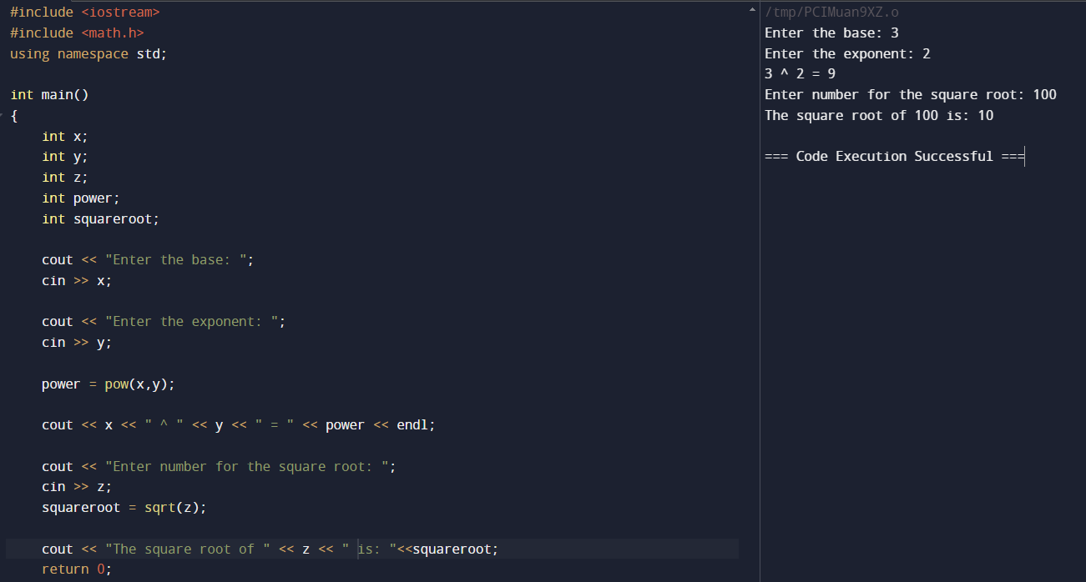

**LAB 20**

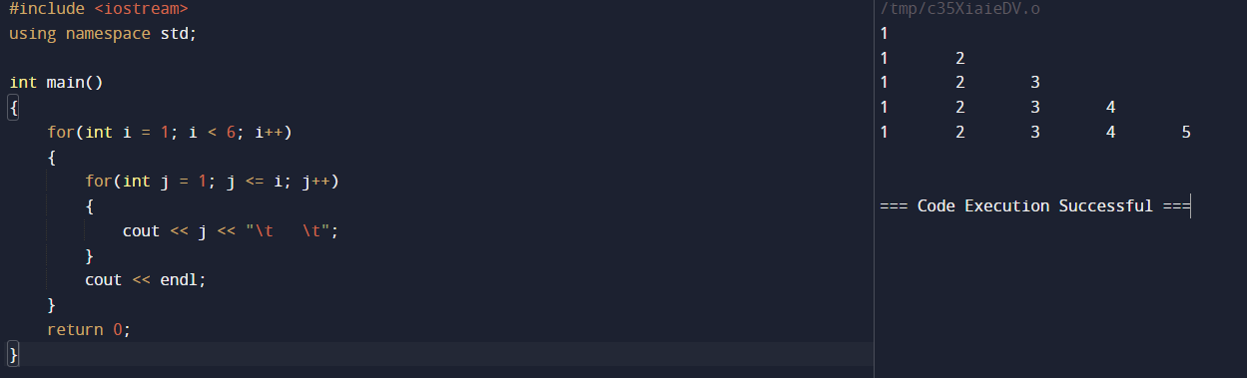

**LAB 21**

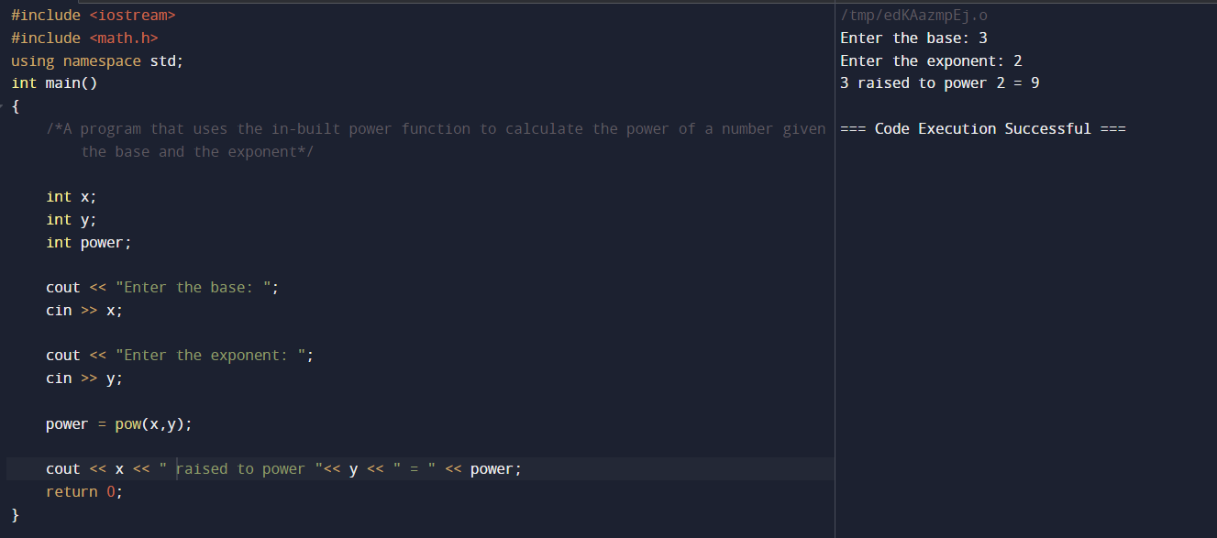

**LAB 22**

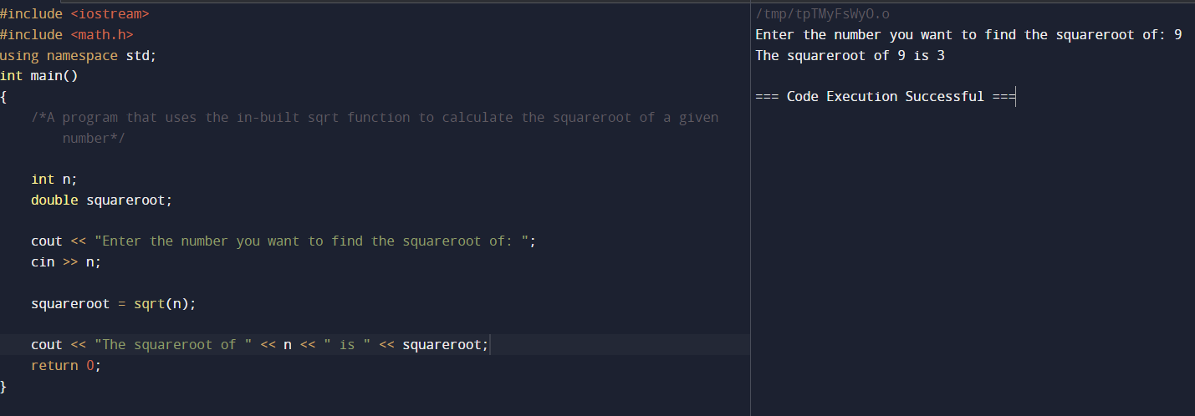

**LAB 23**

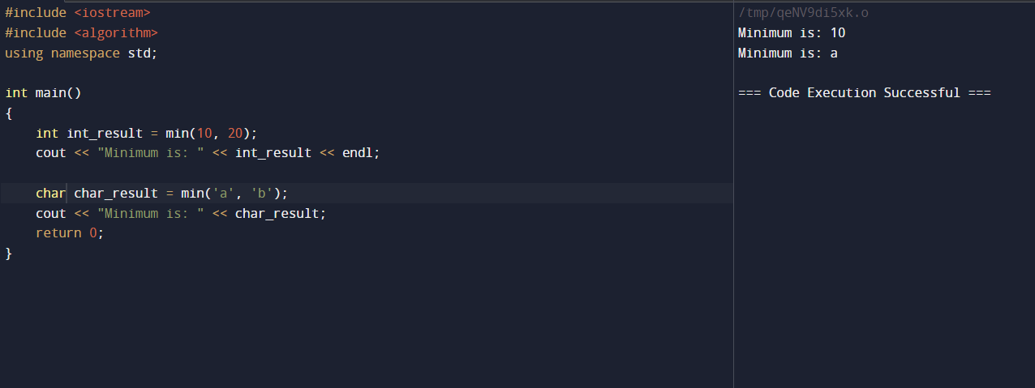

**LAB 24**

**LAB 25**

**LAB 26**

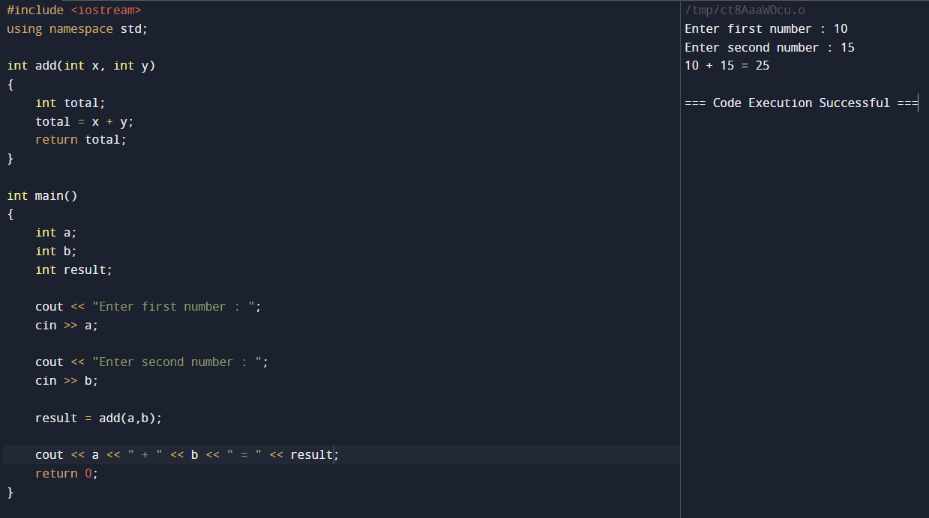

**LAB 27**

**LAB 28**

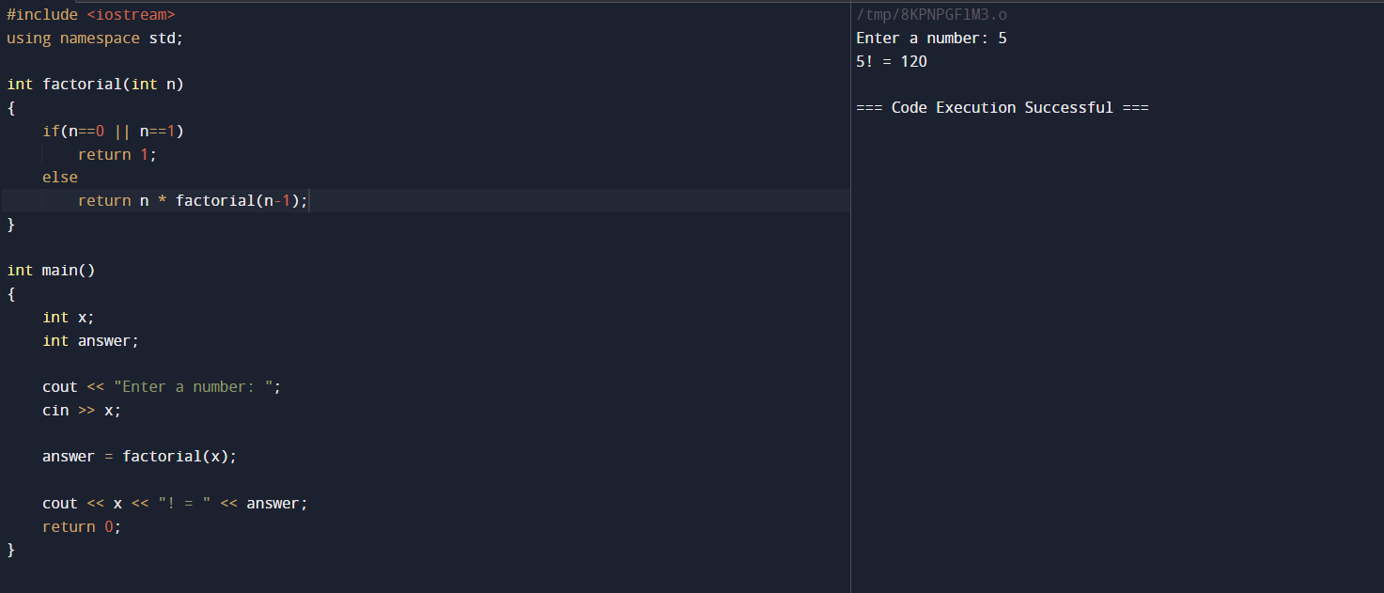

**LAB 29**

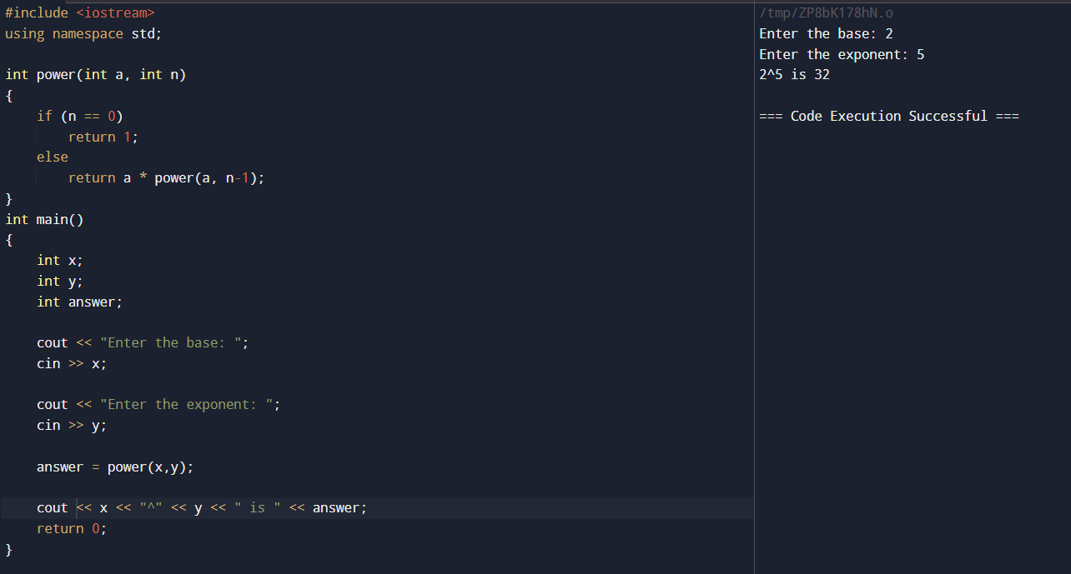

**LAB 30**

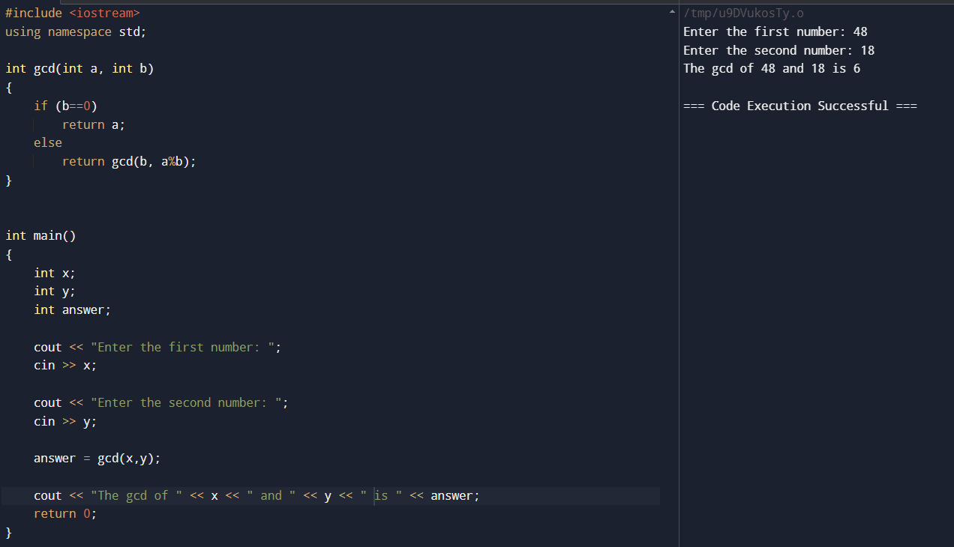

**LAB 31**

**LAB 32**

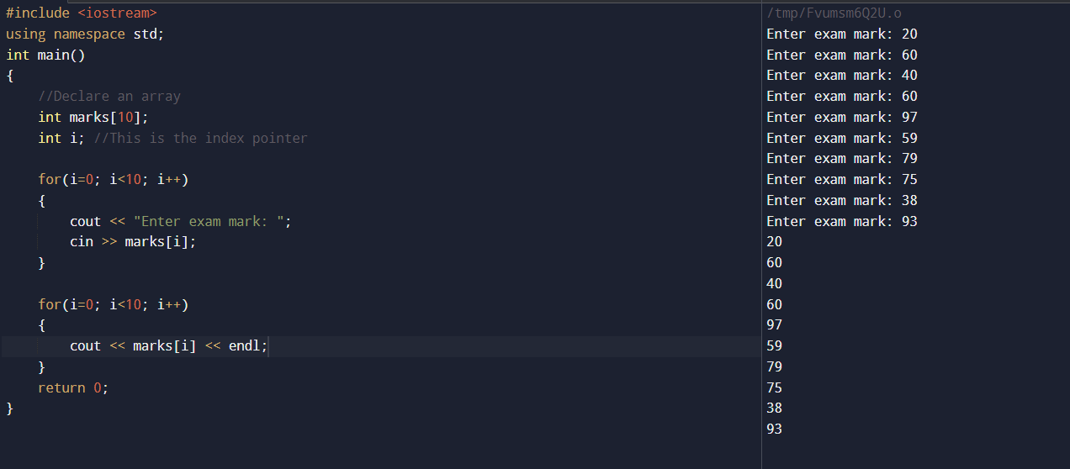

**LAB 33**

**LAB 34**

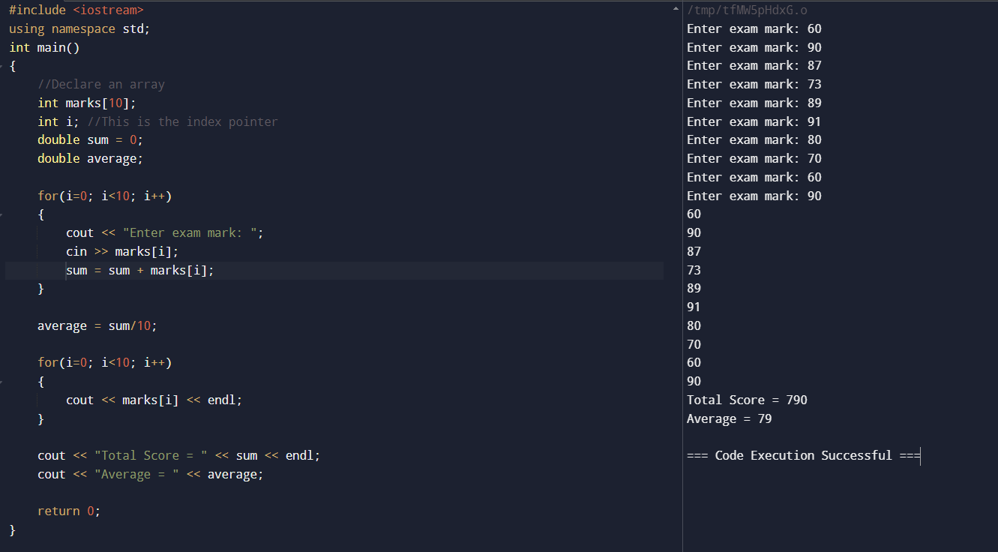

**LAB 35**

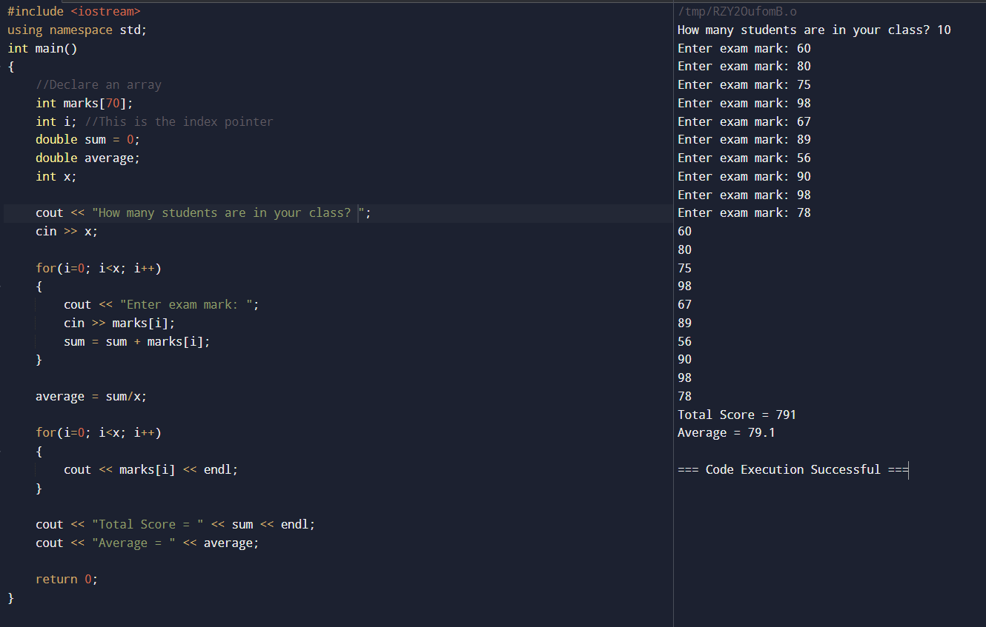

**LAB 36**

**LAB 37**

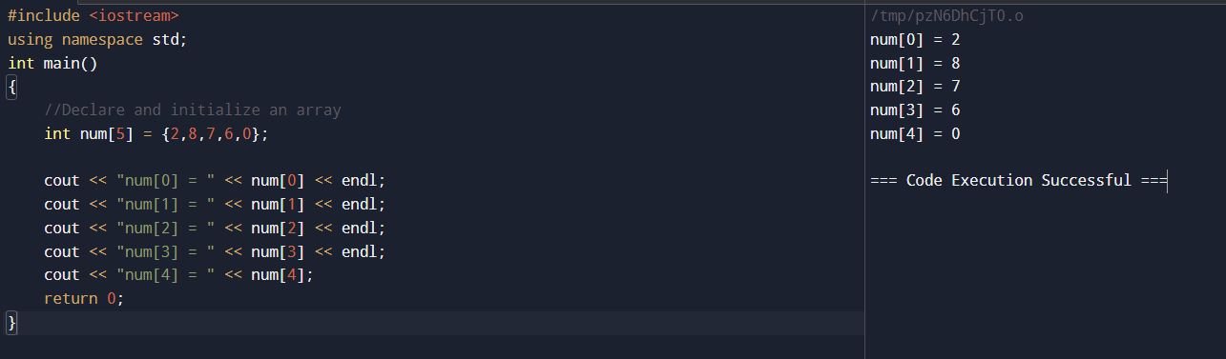

**LAB 38**

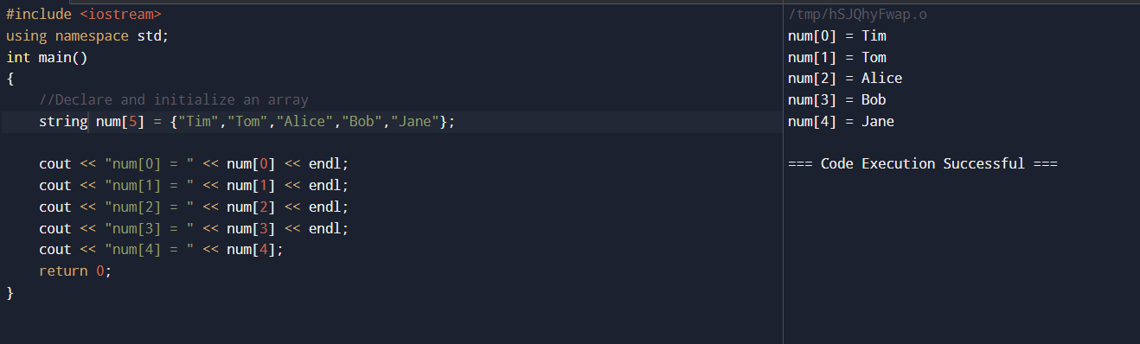

**LAB 39**

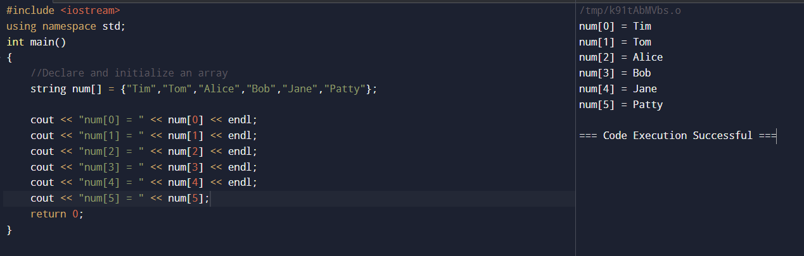

**LAB 40**

**LAB 41**

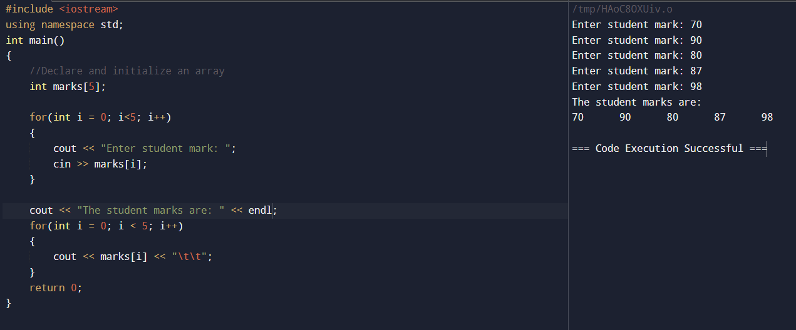

**LAB 42**

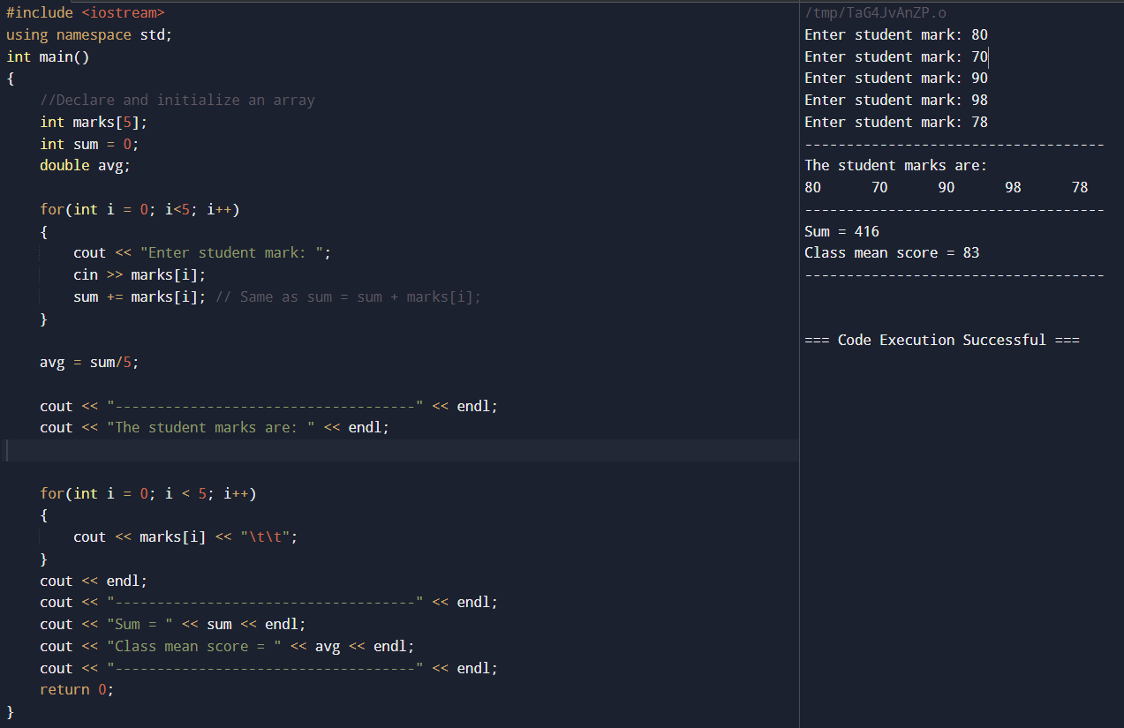

**LAB 43**

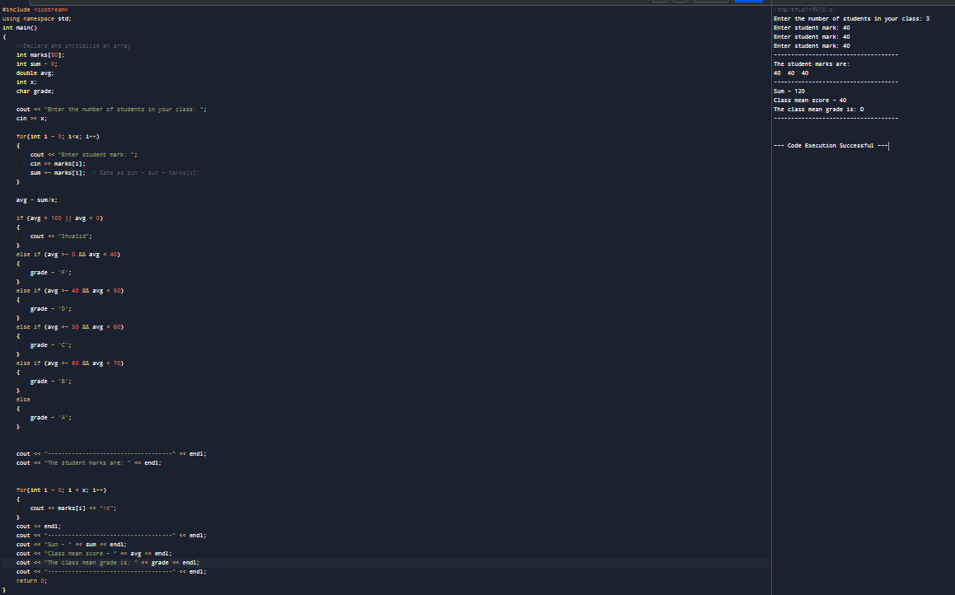

**LAB 44**

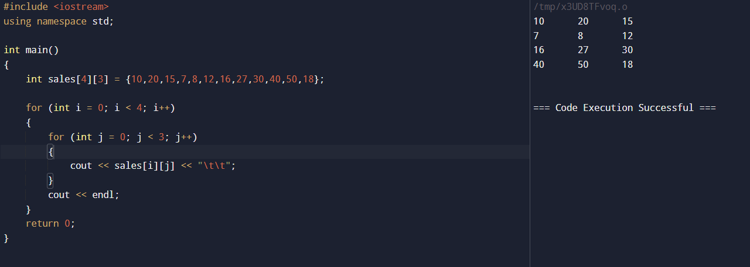

**LAB 45**

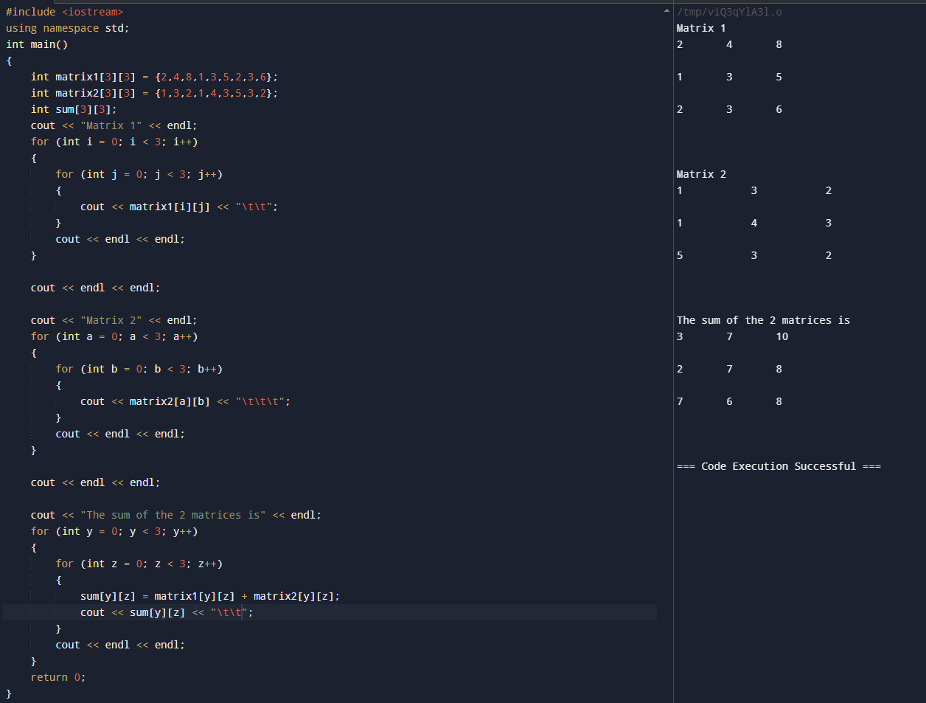

**LAB 46**

C++ program to compute area and circumference of a circle using the following functions:

1. input-radius( ) – to allow a user to enter radius
2. calculate-area( ) – to calculate the area
3. calculate-circumference( ) – to compute circumference
4. display-results( ) – outputs the results after calling the all_operations( ) function
5. all-operations( ) – calls the calculate-area( ) and calculate-circumference( )
6. main( ) – the main C++ function that calls the the display-results( ) function

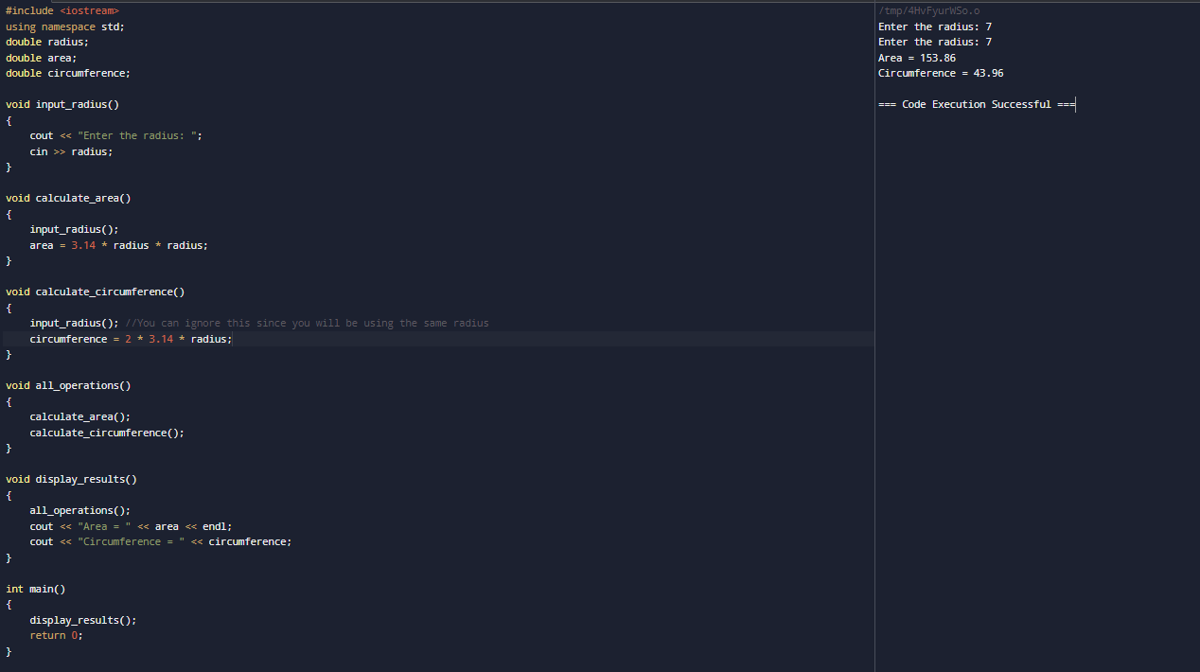

**LAB 47**

**LAB 48**

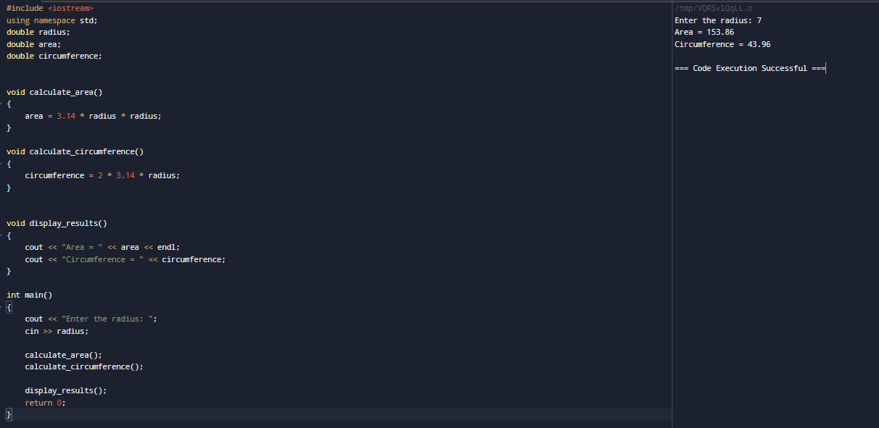

**LAB 49**

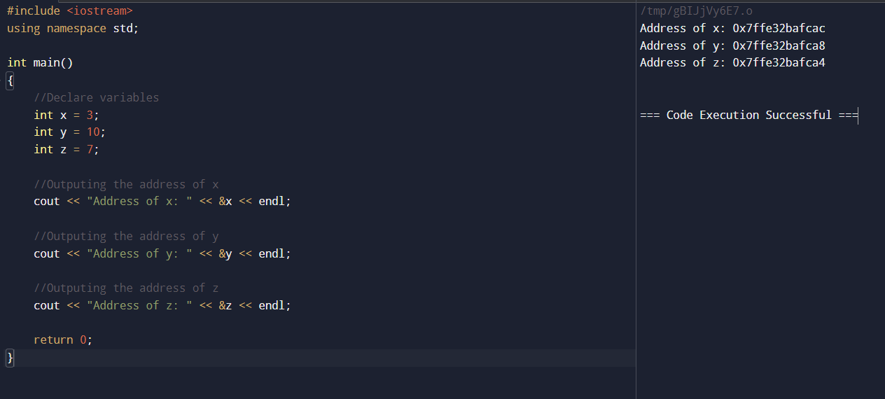

**LAB 50**

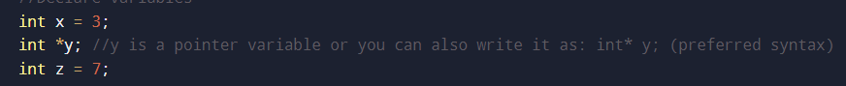

**LAB 51**

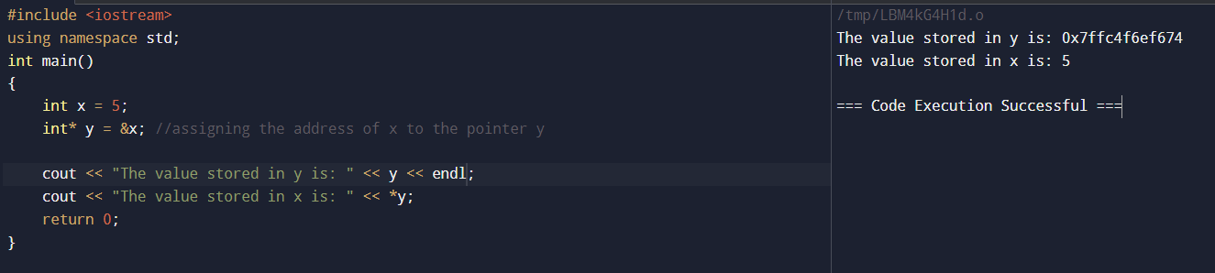

**LAB 52**

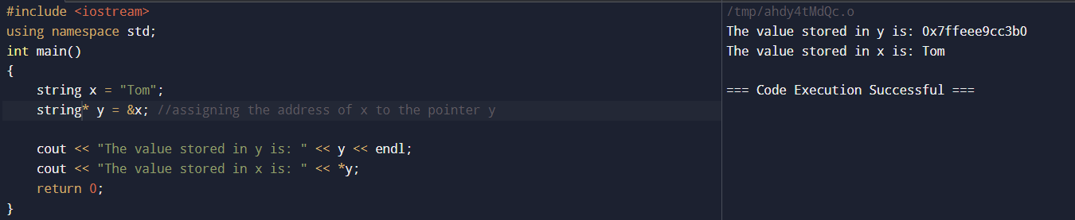

**LAB 53**

Linked List

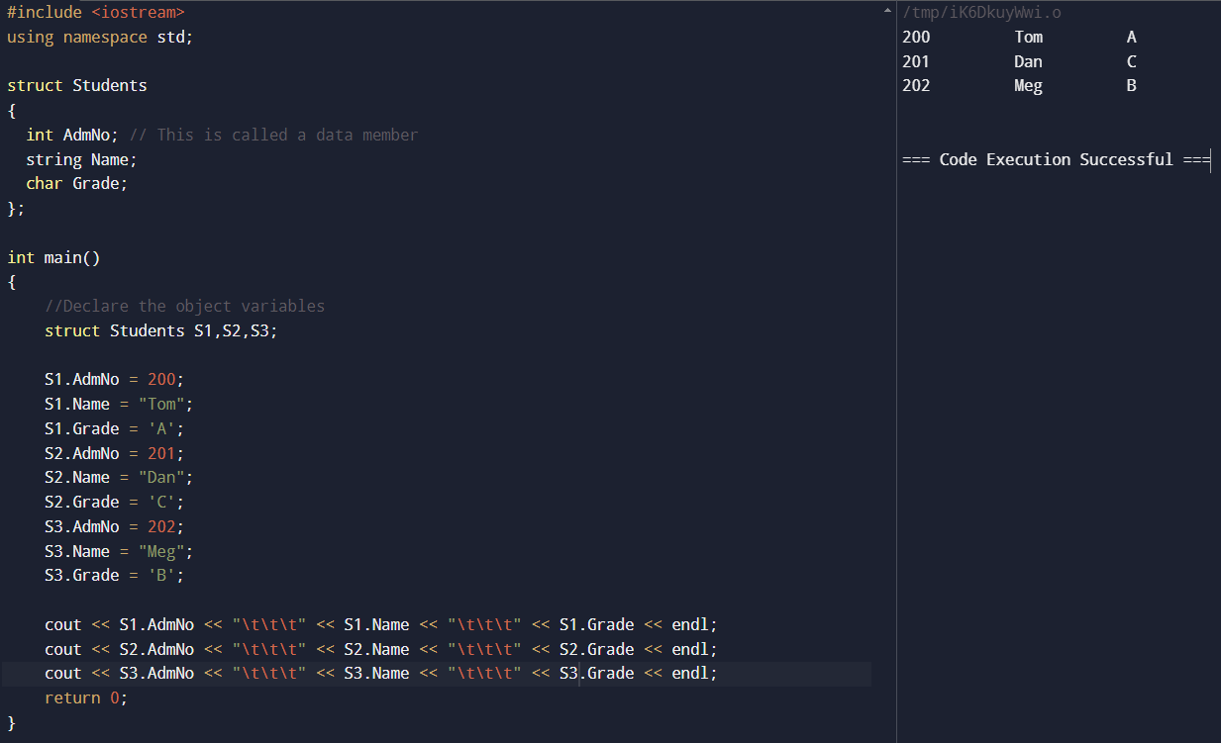

**LAB 54**

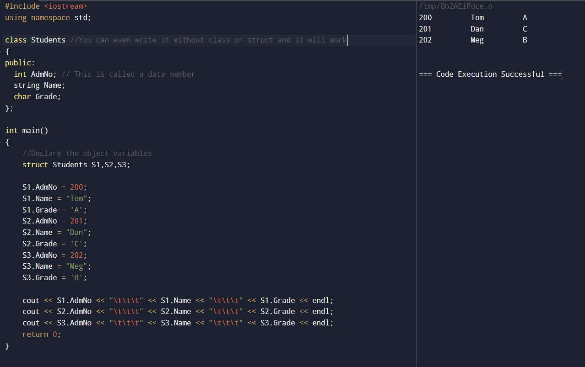

**LAB 55**

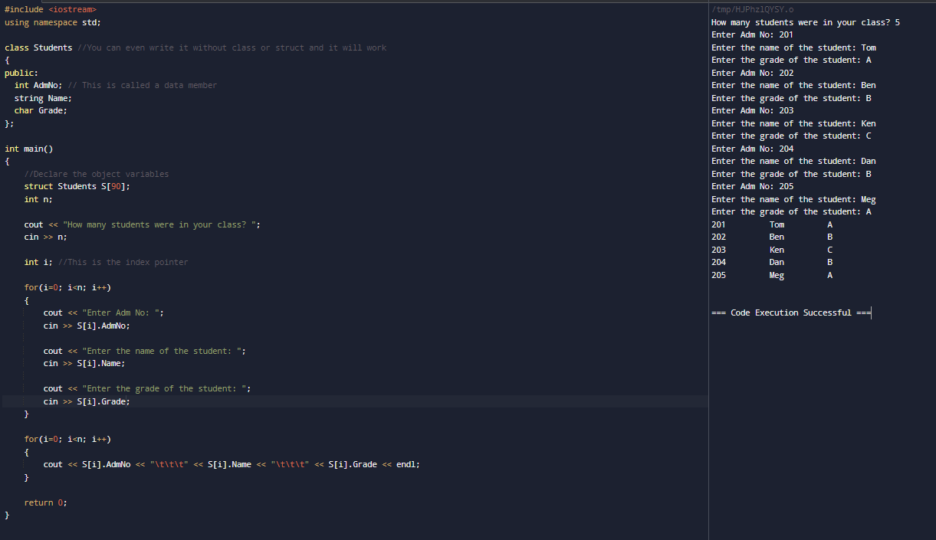

**LAB 56**

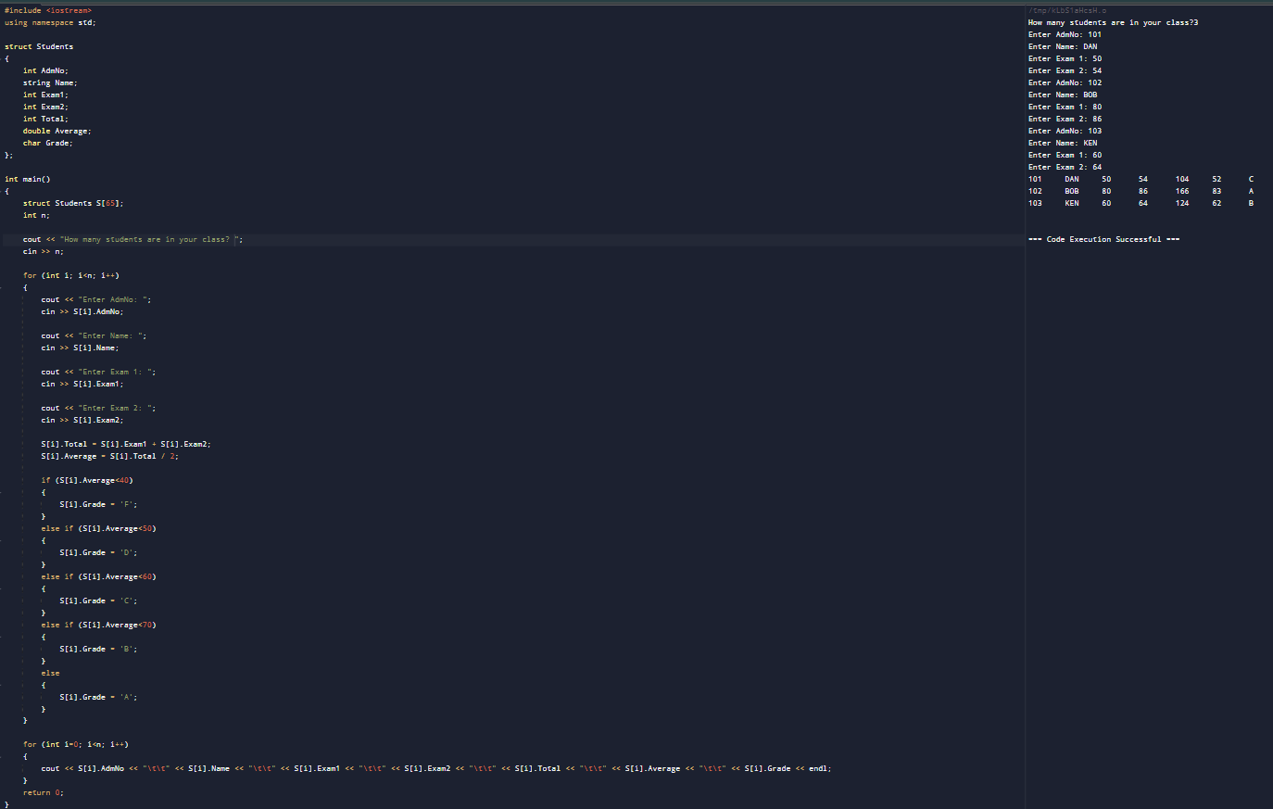

**LAB 57**

